### Semester One Examination, 2018

### Question/Answer booklet

# MATHEMATICS SPECIALIST

**UNIT 3**

## Section One:

## Calculator-free

|  |
| --- |
|  |

Marking Key

## Time allowed for this section

Reading time before commencing work: five minutes

Working time: fifty minutes

## Materials required/recommended for this section

***To be provided by the supervisor***

This Question/Answer booklet

Formula sheet

***To be provided by the candidate***

Standard items: pens (blue/black preferred), pencils (including coloured), sharpener, correction fluid/tape, eraser, ruler, highlighters

Special items: nil

## Important note to candidates

No other items may be taken into the examination room. It is **your** responsibility to ensure that you do not have any unauthorised material. If you have any unauthorised material with you, hand it to the supervisor **before** reading any further.

|  |  |  |  |
| --- | --- | --- | --- |
| Question | Mark | Question | Mark |
| 1 |  | 5 |  |
| 2 |  | 6 |  |
| 3 |  | 7 |  |
| 4 |  | 8 |  |

**Structure of this paper**

|  |  |  |  |  |  |
| --- | --- | --- | --- | --- | --- |
| Section | Number of questions available | Number of questions to be answered | Working time (minutes) | Marks available | Percentage of examination |
| Section One:  Calculator-free | 8 | 8 | 50 | 50 | 35 |
| Section Two:  Calculator-assumed | 13 | 13 | 100 | 95 | 65 |
|  |  |  |  | **Total** | 100 |

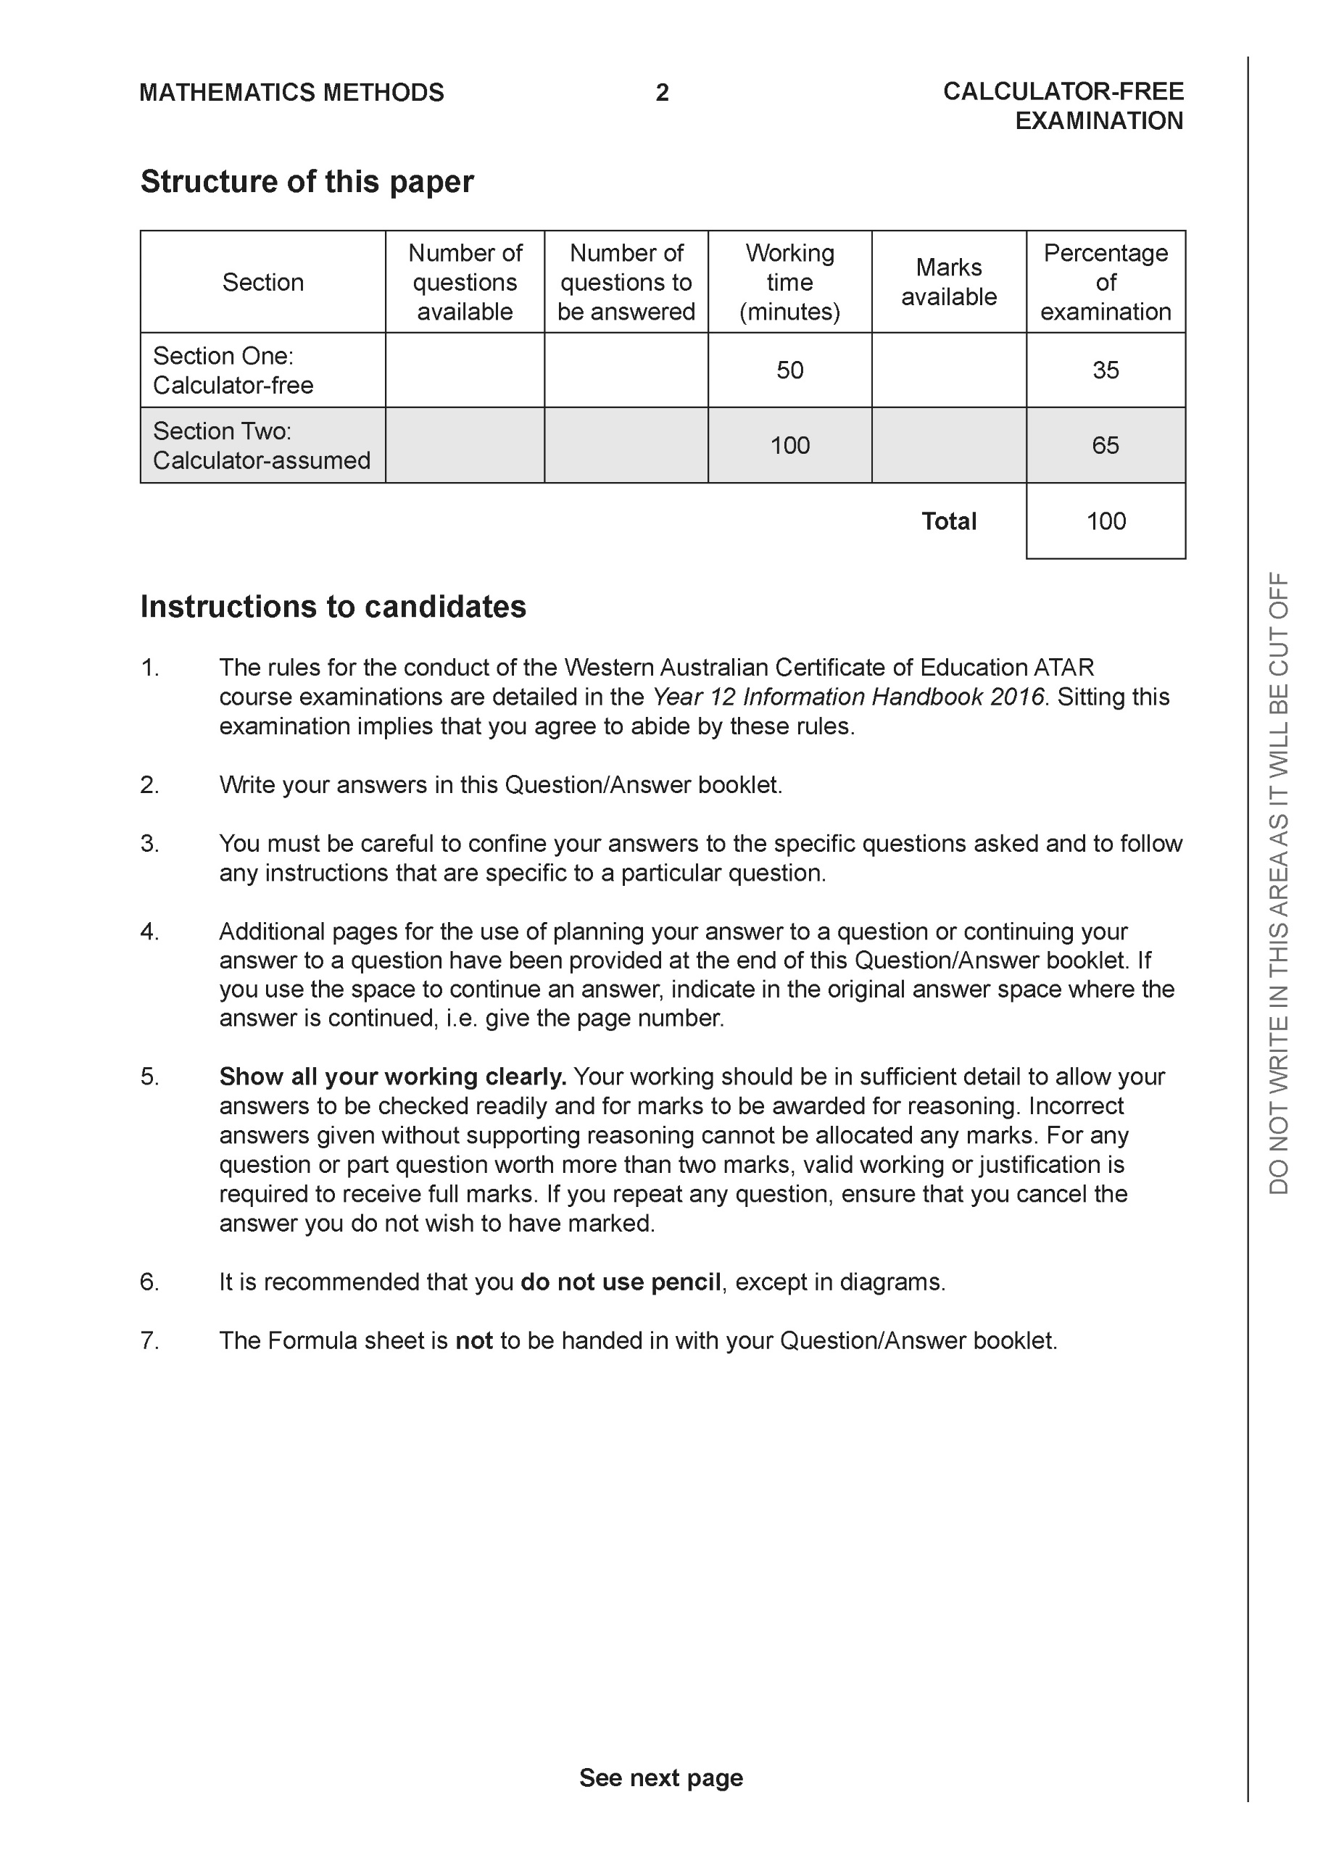

**Section One: Calculator-free (50 Marks)**

This section has **eight (8)** questions. Answer **all** questions. Write your answers in the spaces provided.

Spare pages are included at the end of this booklet. They can be used for planning your responses and/or as additional space if required to continue an answer.

● Planning: If you use the spare pages for planning, indicate this clearly at the top of the page.

● Continuing an answer: If you need to use the space to continue an answer, indicate in the original answer space where the answer is continued, i.e. give the page number. Fill in the number of the question that you are continuing to answer at the top of the page.

Working time: 50 minutes.

**Question 1 (8 marks)**

Consider the polynomial  where 

(a) Determine the roots of  and label them  (2 marks)

|  |
| --- |
| **Solution** |
|  |
| **Specific behaviours** |
| 🗸 uses quadratic formula  🗸 obtains two complex roots |

(b) Determine  (3 marks)

|  |
| --- |
| **Solution** |
|  |
| **Specific behaviours** |
| 🗸 uses conjugates correctly  🗸multiplies correctly  🗸 obtains simplified sum |

(c) Determine  (3 marks)

|  |
| --- |
| **Solution** |
|  |
| **Specific behaviours** |
| 🗸 expands expression in terms of variables  🗸separates sums that give zero  🗸 obtains simplified real result |

**Question 2 (7 marks)**

Let  where  are real numbers.

(a) Show that  (2 marks)

|  |
| --- |
| **Solution** |
|  |
| **Specific behaviours** |
| 🗸 obtains expression for modulus of w  🗸 raises modulus to power of 6 |

(b) The expression can be written in the form  , determine expressions for the real constants  in terms of . (3 marks)

|  |
| --- |
| **Solution** |
|  |
| **Specific behaviours** |
| 🗸 uses conjugate to obtain real denominator  🗸changes both terms to have the same denominator  🗸 obtains final expressions for c & d |

(c) Given that the  and  , determine the . (2 marks)

|  |
| --- |
| **Solution** |
|  |
| **Specific behaviours** |
| 🗸 multiplies Arg(w) by 6  🗸 obtains expression for Arg(w) in terms of pi |

**Question 3 (7 marks)**

Consider the following functions .

 

(a) State the natural domain and range of . (2 marks)

|  |
| --- |
| **Solution** |
| Domain  Range |
| **Specific behaviours** |
| 🗸 states domain  🗸 states range |

(b) State the natural domain and range of  (3 marks)

|  |
| --- |
| **Solution** |
|  |
| **Specific behaviours** |
| 🗸 uses domain of f(x)  🗸uses rule to find range  🗸 states range |

(c) Does  exist over the natural domain of ? Explain. (2 marks)

|  |
| --- |
| **Solution** |
|  |
| **Specific behaviours** |
| 🗸 states condition for existence  🗸 states relevant domain and ranges |

**Question 4 (7 marks)**

Consider the function  ,  which is plotted on the axes below.

(a) Sketch the inverse function  on the axes above. (3 marks)

|  |
| --- |
| **Solution** |
|  |
| **Specific behaviours** |
| 🗸 vertex of (7,3) plotted  🗸reflected in line y=x  🗸 x intercept of (16,0) plotted |

(b) Determine the rule for the inverse function and state the domain and range.

(4 marks)

|  |
| --- |
| **Solution** |
|  |
| **Specific behaviours** |
| 🗸 interchanges x and y  🗸completes the square or uses quadratic formula  🗸 obtains expression for inverse with minus sign  🗸states domain and range of inverse |

**Question 5 (5 marks)**

Consider the graph of  which is graphed below.

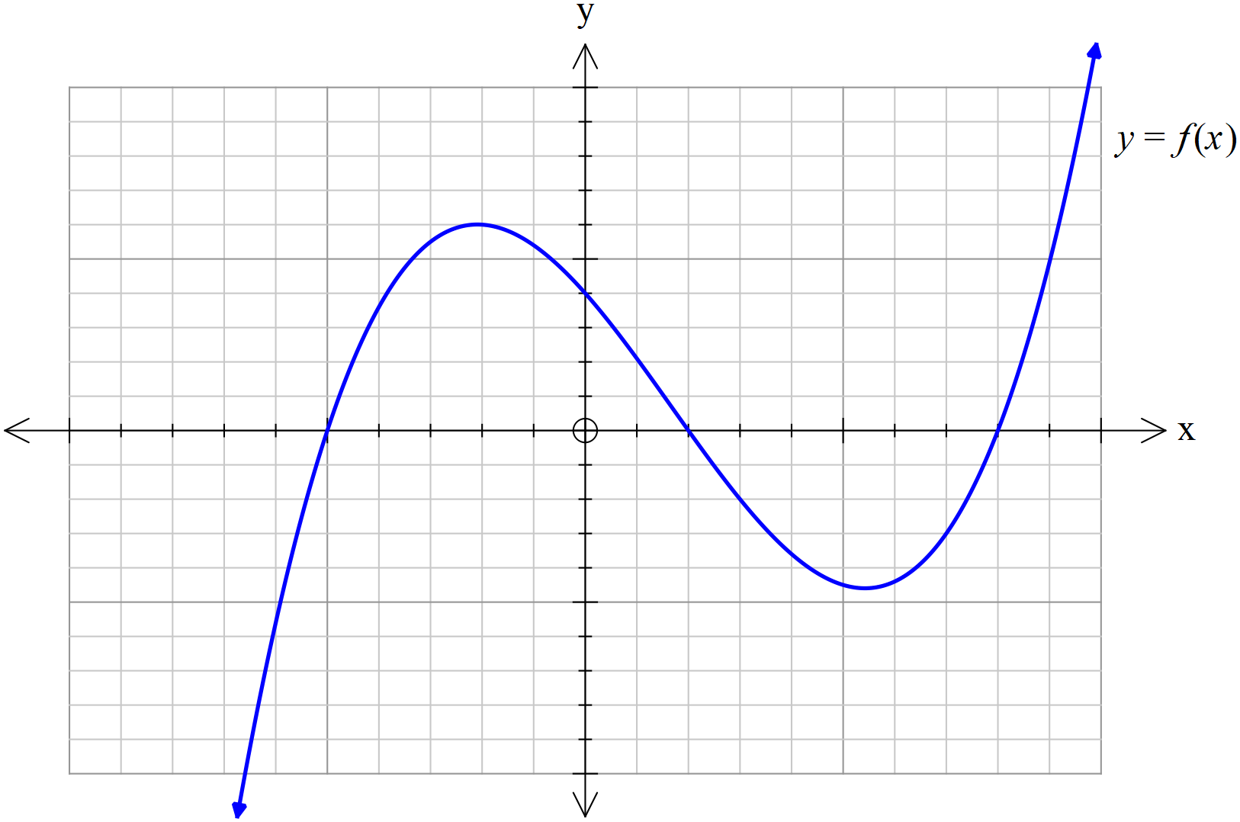

(a) On the axes below, sketch  (2 marks)

|  |
| --- |
| **Solution** |
|  |
| **Specific behaviours** |
| 🗸 right side reflected in y axis  🗸 correct x , y intercepts and turning point on LHS |

(b) On the axes below, sketch  (3 marks)

|  |
| --- |
| **Solution** |
|  |
| **Specific behaviours** |
| 🗸lateral symmetry  🗸only plotted on and below x axis  🗸 correct x, y intercepts and turning points |

**Question 6 (6 marks)**

Sketch the graph of  on the axes below.

|  |
| --- |
| **Solution** |
|  |
| **Specific behaviours** |
| 🗸 vertical asymptotes at x =-4 & 3  🗸horizontal asymptote ay y=2  🗸 y intercept near y=2/3  🗸x intercepts at x=-2,2  🗸 correct shape between vertical asymptotes  🗸correct shape outside asymptotes |

**Question 7 (5 marks)**

A triangular prism OACB is shown below with O as the origin and points A, B & C have respective position vectors  Point P lies on the line  in the ratio .

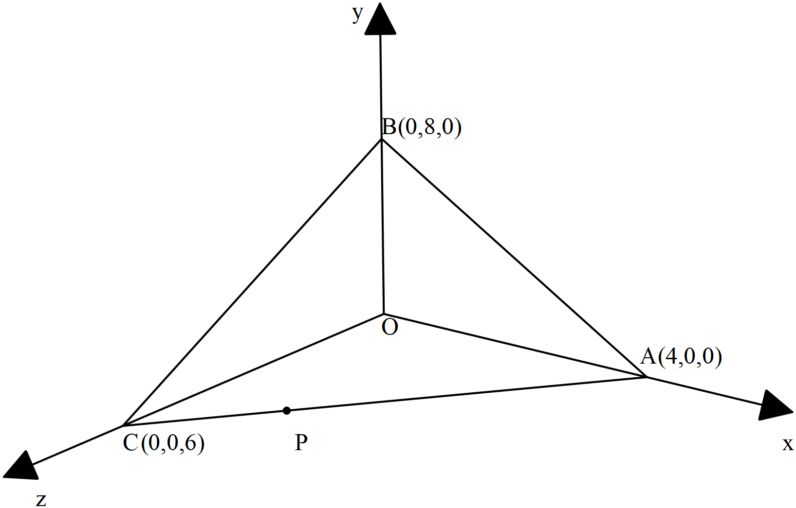

(a) Determine the vector equation of the line that passes through points 

( 2 marks)

|  |
| --- |
| **Solution** |
|  |
| **Specific behaviours** |
| 🗸 determines point P  🗸 Determines vector equation of line |

(b) Determine the cartesian equation of the plane that contains points .

( 3 marks)

|  |
| --- |
| **Solution** |
|  |
| **Specific behaviours** |
| 🗸 determines two vectors in plane  🗸uses cross product to obtain normal vector  🗸 determines cartesian equation from vector equation of plane |

**Question 8 (5 marks)**

Consider a circle in the complex plane where the centre is given by  and a radius of 5 units. Let  be a point on this circle where  with  and 

(a) Determine  in exact cartesian form . ( 3 marks)

|  |
| --- |
| **Solution** |
|  |
| **Specific behaviours** |
| 🗸 uses y=3x for point P  🗸subs y=3x into cartesian equation of circle  🗸 identifies 3+9i as only solution for P |

(b) Sketch this circle and point P in the complex plane below showing all major features.

( 2 marks)

|  |
| --- |
| **Solution** |
|  |
| **Specific behaviours** |
| 🗸 sketches circle with correct centre and radius going through (0,0)  🗸 shows point P to be on circle at (3,9) |

Additional working space

Question number:

Additional working space

Question number:

Additional working space

Question number:

Additional working space

Question number:

Additional working space

Question number:

**Acknowledgements**